**Tanagra**

Follow the below instruction to download Tanagra and include it as Add-ins in Excel

1. Download the Tanagra file from the link below

<http://eric.univ-lyon2.fr/~ricco/tanagra/en/tanagra.html>

1. Go to ‘Download’ in the link given above and click ‘setup’ under the contents

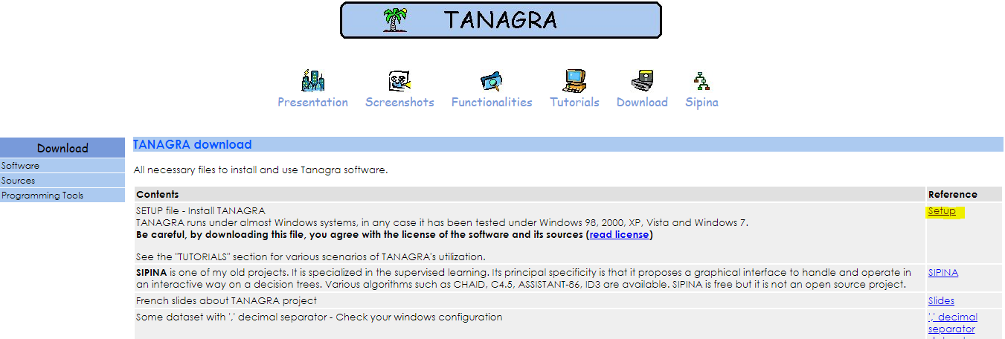

1. Download the .exe file.
2. Run the .exe file to install the Tanagra application
3. Go to the location where the Tanagra is installed and locate the .xla file

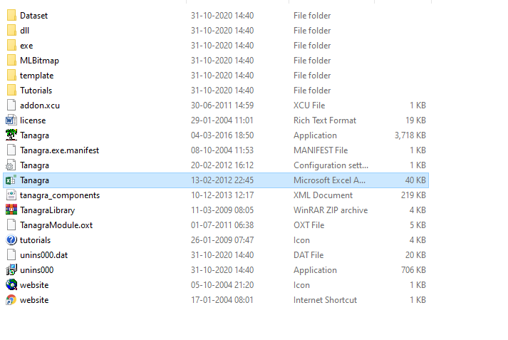

1. Open Excel and go to File -> Options -> Add-ins
2. Here set Manage as Excel Add ins and click go
3. In the Add-ins dialog box, select ‘Browse’ then navigate and select the Tanagra.xla file.
4. Click ok. Now you should be able to find the Tanagra add-in in excel under the Add-ins

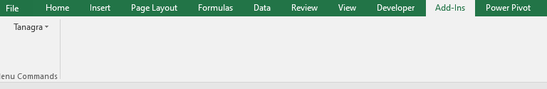

**Sipina**

Follow the below instructions to download Sipina and include it as add-ins in Excel

1. Download Sipina from the link given below

<http://eric.univ-lyon2.fr/~ricco/sipina.html>

1. Click ‘sipina research’ under software to download the .exe file

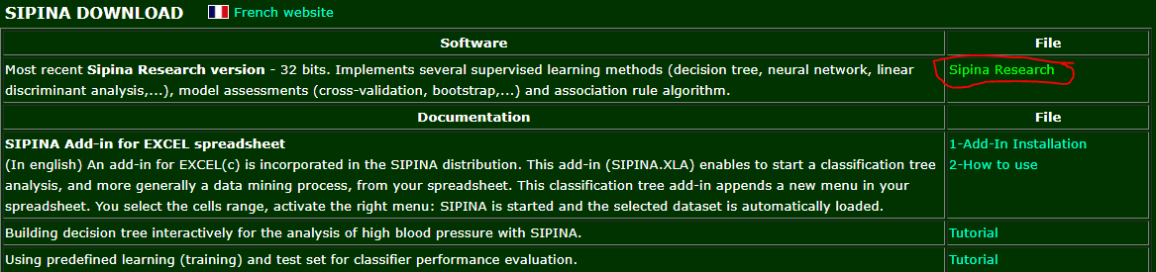

1. Download and run the .exe file to install sipina
2. Similar to Tanagra add sipina as the add-ins
3. Open Excel and go to File -> Options -> Add-ins
4. Here set Manage as Excel Add ins and click go
5. In the Add-ins dialog box, select ‘Browse’ then navigate and select the sipina.xla file. (This should be under the folder ‘StatPackage’)
6. Click ok. Now you should be able to find the Sipina add-in in excel under the Add-ins



**RegressIt**

1. Download regress it from the below link

<https://regressit.com/regressitlogistic.html>

1. Click ‘[RegressItLogistic.zip](http://regressit.com/RegressItLogistic.zip)**’ and download the zip file**

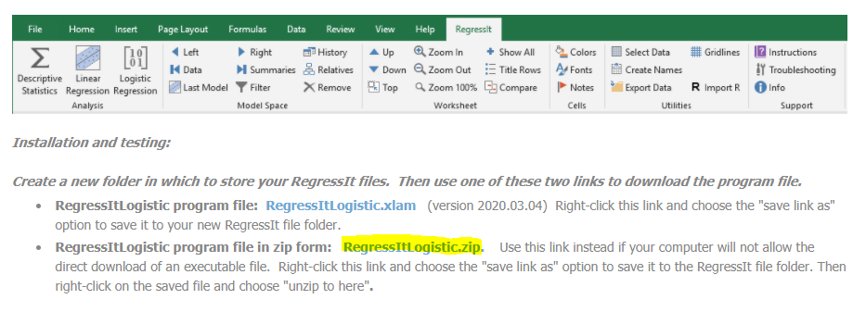

1. **Unzip the folder and keep at your desired location**
2. This folder should have the RegressItLogistic.xla file
3. Open Excel and go to File -> Options -> Add-ins
4. Here set Manage as Excel Add ins and click go
5. In the Add-ins dialog box, select ‘Browse’ then navigate and select the RegressItLogistic.xla file.
6. Click Ok, now a new menu should appear on the excel as below.

